**Practical Number 2**

Aim: Create a website using the master page concept.

**Overview of the Master Page Concept**

The **Master Page** allows you to define a consistent layout and design for multiple pages in a web application. Content pages can use the master page to inherit this layout while providing their unique content.

**1. Steps to Create the Website**

**Step 1: Create an ASP.NET Web Forms Project**

1. Open Visual Studio.
2. Create a new project: **ASP.NET Web Forms Application**.
3. Name the project WebsiteWithMasterPage.

**Step 2: Add a Master Page**

1. Right-click on the project in **Solution Explorer**.
2. Select **Add** > **New Item** > **Web Forms Master Page**.
3. Name it SiteMaster.master.

**SiteMaster.master**

This is the layout for the website.

<%@ Master Language="C#" AutoEventWireup="true" CodeFile="SiteMaster.master.cs" Inherits="SiteMaster" %>

<!DOCTYPE html>

<html>

<head>

<title>My Website</title>

<link rel="stylesheet" href="styles.css" />

</head>

<body>

<div class="header">

<h1>Welcome to My Website</h1>

<nav>

<a href="Home.aspx">Home</a>

<a href="About.aspx">About</a>

<a href="Contact.aspx">Contact</a>

</nav>

</div>

<div class="content">

<asp:ContentPlaceHolder ID="MainContent" runat="server"></asp:ContentPlaceHolder>

</div>

<div class="footer">

<p>&copy; 2025 My Website. All Rights Reserved.</p>

</div>

</body>

</html>

**Step 3: Add Content Pages**

1. Right-click on the project in **Solution Explorer**.
2. Select **Add** > **New Item** > **Web Form with Master Page**.
3. Name the page Home.aspx and link it to SiteMaster.master.
4. Repeat to create About.aspx and Contact.aspx.

**Home.aspx**

<%@ Page Title="Home" Language="C#" MasterPageFile="~/SiteMaster.master" AutoEventWireup="true" CodeFile="Home.aspx.cs" Inherits="Home" %>

<asp:Content ID="Content1" ContentPlaceHolderID="MainContent" runat="server">

<h2>Welcome to the Home Page</h2>

<p>This is the main content of the Home page.</p>

</asp:Content>

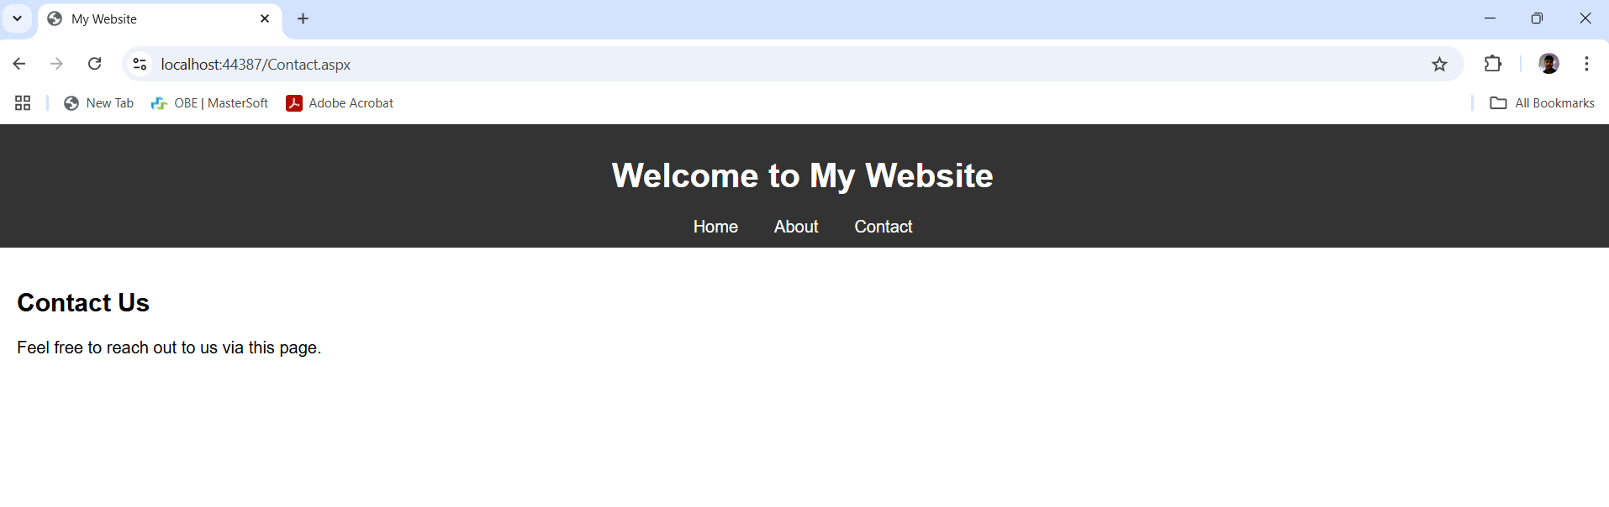

**About.aspx**

<%@ Page Title="About" Language="C#" MasterPageFile="~/SiteMaster.master" AutoEventWireup="true" CodeFile="About.aspx.cs" Inherits="About" %>

<asp:Content ID="Content1" ContentPlaceHolderID="MainContent" runat="server">

<h2>About Us</h2>

<p>Learn more about our organization on this page.</p>

</asp:Content>

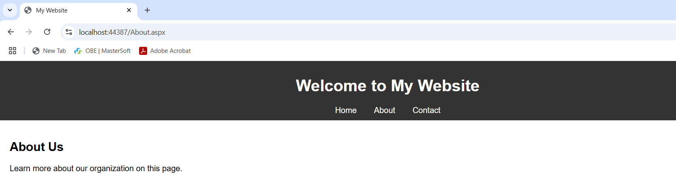

**Contact.aspx**

<%@ Page Title="Contact" L

anguage="C#" MasterPageFile="~/SiteMaster.master" AutoEventWireup="true" CodeFile="Contact.aspx.cs" Inherits="Contact" %>

<asp:Content ID="Content1" ContentPlaceHolderID="MainContent" runat="server">

<h2>Contact Us</h2>

<p>Feel free to reach out to us via this page.</p>

</asp:Content>

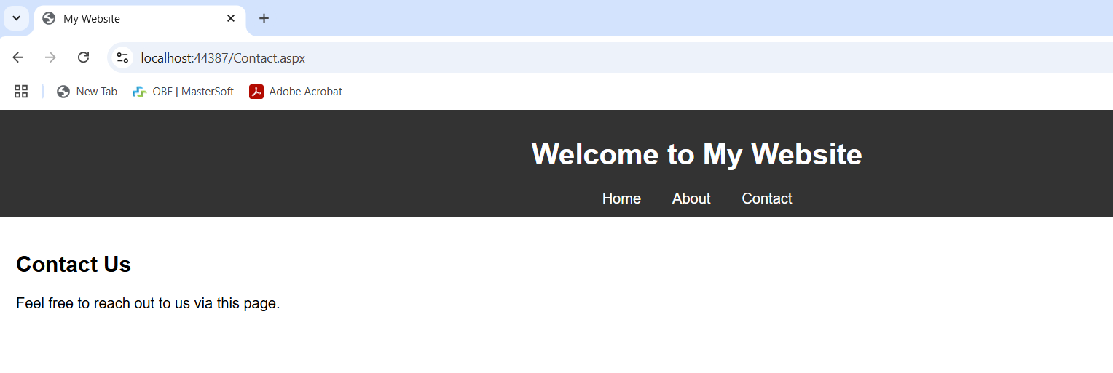

**Step 4: Add CSS for Styling**

1. Right-click the project in **Solution Explorer**.
2. Add a new folder named Content and a new file styles.css inside it.

**styles.css**

body {

font-family: Arial, sans-serif;

margin: 0;

padding: 0;

}

.header {

background-color: #333;

color: white;

padding: 10px;

text-align: center;

}

.header nav a {

color: white;

text-decoration: none;

margin: 0 15px;

}

.header nav a:hover {

text-decoration: underline;

}

.content {

padding: 20px;

}

.footer {

background-color: #333;

color: white;

text-align: center;

padding: 10px;

position: fixed;

width: 100%;

bottom: 0;

}

**Step 5: Run the Application**

* Press **F5** to run the application.
* Navigate between the Home.aspx, About.aspx, and Contact.aspx pages. Each page will have a consistent layout inherited from SiteMaster.master.

**Key Advantages of Using Master Pages**

1. **Consistency**: Provides a unified layout for all pages.
2. **Maintainability**: Changes to the master page automatically reflect on all linked pages.
3. **Code Reusability**: Common elements like navigation bars and footers are defined only once.